**RWBY RPG COMBAT ENGINE**

**Design Document**

**Genre:** Fighting

**Game Modes**: Multiplayer

**Concept:** The concept of this project is to be a demo of a combat engine for a RPG like game. It is to be 1 vs. 1 multiplayer. Larger battles may be a concept for the future but would likely need a significant reworking of the gameplay mechanics. No AI is currently planned.

**Gameplay:**

**Stats:**

Health: The health of the character. Losing all health is a loss condition. Float displayed as Integer.

Defense: The ability of the character to reduce incoming damage. Percentage.

Melee: The strength of melee attacks of the character. Percentage.

Ranged: The strength of ranged attacks of the character. Percentage.

Spirit: The ability of the character to regenerate their aura. Percentage

Endurance: The amount of aura a character has. Float displayed as Integer.

Dodge: The chance of a character dodging attacks, affected by distance and aura remaining. Percentage.

Speed: Determines attack order, affected by aura remaining. Float.

**Mechanics:**

**Health:** The amount of damage a character can take before they collapse. Defense helps prevent damage to health.

**Aura:** Used for the majority of actions including attacking, moving, and using semblances. Amount of aura is determined by endurance and regeneration amount each turn is determined by spirit. Amount remaining effects Dodge chance, Speed. and Defence.

**Turns:** Every game turn is split into two or three phases. During the first phase the player can either move, defend, use their active semblance, or skip the phase. During phase two the player may attack and/or defend. In phase two the character’s speed determines action order and it is possible to attack an opponent before they fully defend. Phase two becomes phase three if a active semblance is used and the new phase two allows to move if they haven't already or skip.

**Position:** The battlefield is laid out as a 1x8 grid. Characters can move one square with a 25% attack penalty, or 2 squares with a 50% attack penalty. Attack penalties last till the end of the turn and are multiplicative of other penalties. If you move more than 4 spaces within 3 consecutive turns without the use of a semblance, you will lose 3% aura per space exponentially. ex. 5th=3% 6th=6% 7th=9% etc. The distance between opponents also effects dodge chance. If opponents are adjacent the base dodge chance is used. and 2% is added for every further square for attacks.

**Attacking:** Each character has 3 base attacks. Melee, short ranged, and long ranged. Melee can be used 1 square away and does heavy damage. Short ranged can be used 2 to 4 squares away and does light damage. And long ranged can be used 5 or more squares away and does heavy damage. Heavy attacks have 115 health base damage and take 100 aura, light attacks have a 75 base damage and take 60 aura. Base damage is modified by melee and ranged stats. Attacks do half of their base damage to the target’s aura.

**Defending:** If defending is used in phase one it reduces incoming damage by 35% and outgoing damage by 50%. If defending is used in phase two it only reduces incoming damage as you can no longer attack. if defending is used in phase one and two it takes a 5% aura penalty but reduces incoming damage by 55%. If defending is used in phase two but the opponent is faster it only reduces damage by 10%. If defending was used in phase two after it was also used in phase one but the opponent is faster incoming damage is only reduced by 15% Defense damage reduction is calculated before a character’s base defense which is then calculated on the amount left from defending.

**Semblance:** Every character has a passive semblance and an active semblance. Passive semblances give slight bonuses to characters and active semblances can be used during a turn. Using a semblance requires the entire turn and adds another phase to the turn. They typically cost a larger amount of aura that is dependent on the character. Effects vary from character to character and will be explained in the character section.

**Characters:**

**Ruby Rose:**

**Stats:**

Health: 500

Defense: 15%

Melee: 90%

Ranged: 110%

Spirit: 15%

Endurance: 300

Dodge: 9%

Speed: 11

**Attacks:** (Attack Names Temporary)

**Ranged:**

Aimed Shot (Heavy)

Quick Shot (Weak)

**Melee:**

Heavy Cut (Heavy)

**Semblance:** Agility

**Passive:** Ruby’s damage penalties for moving are reduced to 20% for 1 square and 40% for 2 squares.

**Active:** Speed Boost. Allows Ruby to move one space with no damage penalty, two with a 20% penalty, 3 with a 50% penalty, and 4 with a 80% penalty. Takes 5% aura per square.

**Yang Xiao Long:**

**Stats:**

Health: 650

Defense: 25%

Melee: 110%

Ranged: 80%

Spirit: 9%

Endurance: 450

Dodge: 4%

Speed: 6

**Attacks:** (Attack Names Temporary)

**Ranged:**

Aimed Slug (Heavy)

Slug Barrage (Weak)

**Melee:**

Shotgun Punch (Heavy)

**Semblance:** Damage Sponge

**Passive:** As her health gets lower her stats go up. They will continue to rise until 15% health is left. Defense can be increased by 10%, Melee and Ranged by 20%, Spirit by 3%, Dodge by 3%, and Speed by 2.

**Active:** Super Saiyang. Can only be activated at under 50% health. Allows Yang to move 3 squares in a turn with no damage penalty and a 5% aura penalty per square. Increases Defense by 10%, Melee and Ranged attack by 15%, Dodge by 5%. and Speed by 2. Stat increases stack additively with the passive increases. Stat increases are only valid during the turn the Semblance is activated and it disables the passive Semblance for two turns after.

**UI:**

**Main Menu:**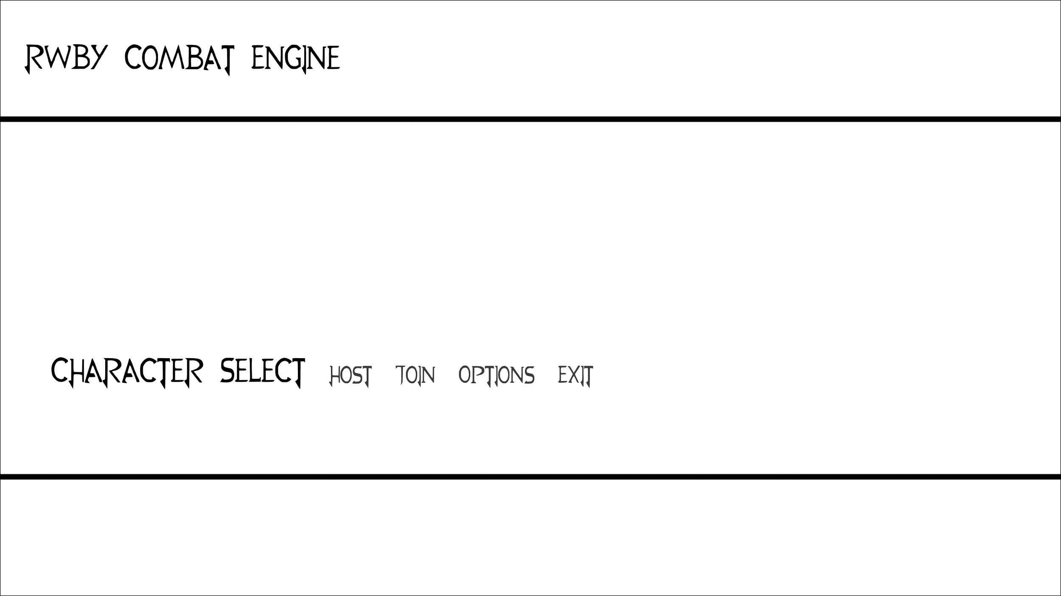

**Character Select:**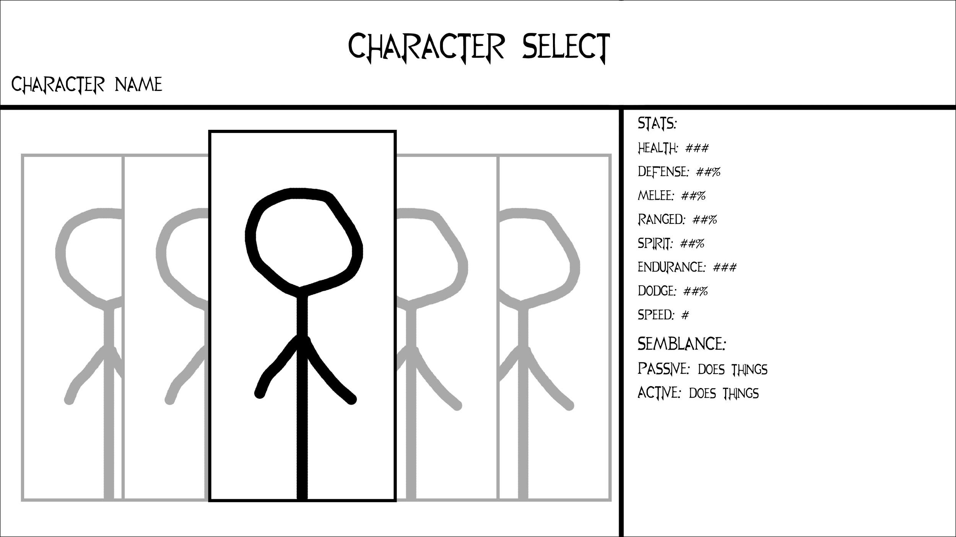

**Battle:**

